**Capstone 5 Project – E-Bike Delivery Services**

**A Full Report**

**By Nancy Currie**

1. **Introduction**
   1. **Background**

San **Francisco** is a densely developed, 47 square mile peninsula with a population of nearly 800 thousand people living in 315 thousand households. One of the most ethnically diverse places in the nation, San Francisco has no ethnic majority. The income range of city residents includes extremes of wealth and poverty, but on average, San Franciscans are richer than residents of most American cities. Average household income of 68,000 is well above the national average, but below the Bay Area average of 76,000. City residents also are better educated than most Americans, with 22% holding a bachelor’s degree, and 13% holding a graduate or professional degree.

San Francisco is unique among California counties in that nearly half (46%) of its labor force is housed outside the city. The city's housing stock of 340 thousand units is relatively old, reflecting the age of the city and public policy that has restricted housing production over the last 30 years. Some 56% percent of housing units was constructed prior to 1940, and 81% prior to 1960. Single family units are less than one-third of the city's housing stock, compared with more than two-thirds in the metropolitan area outside the city. Roughly one-third of city residents own their homes, compared with two-thirds of metro area residents.

San Francisco's economy is intricately linked to regional, national, and international markets. Although many San Francisco jobs are in resident-serving businesses, the growth and development of the city's economy depends on industries oriented to external markets. These export industries form the city's economic base and drive growth in all segments of the local economy, including resident-serving businesses. The rate of economic growth in San Francisco depends on the rate of growth in larger economic venues, the number and type of jobs they create, and the share of these new jobs the city can capture. The city has no way to influence the rate of growth in the state or national economy. Its influence on local economic growth arises exclusively from its determination of factors that affect the location and expansion decisions of industries that form San Francisco's economic base.

**New York City (NYC),** often simply called New York, is the most populous city in the United States. With an estimated 2019 population of 8,336,817 distributed over about 302.6 square miles (784 km2), New York City is also the most densely populated major city in the United States. Located at the southern tip of the U.S. state of New York, the city is the center of the New York metropolitan area, the largest metropolitan area in the world by urban landmass. With almost 20 million people in its metropolitan statistical area and approximately 23 million in its combined statistical area, it is one of the world's most populous megacities. New York City has been described as the cultural, financial, and media capital of the world, significantly influencing commerce, entertainment, research, technology, education, politics, tourism, art, fashion, and sports. Home to the headquarters of the United Nations, New York is an important center for international diplomacy.

Situated on one of the world's largest natural harbors, New York City is composed of five boroughs, each of which is a county of the State of New York. The five boroughs—Brooklyn, Queens, Manhattan, the Bronx, and Staten Island—were consolidated into a single city in 1898. The city and its metropolitan area constitute the premier gateway for legal immigration to the United States. As many as 800 languages are spoken in New York, making it the most linguistically diverse city in the world. New York is home to more than 3.2 million residents born outside the United States,the largest foreign-born population of any city in the world as of 2016.As of 2019, the New York metropolitan area is estimated to produce a gross metropolitan product (GMP) of $2.0 trillion. If the New York metropolitan area were a sovereign state, it would have the eighth-largest economy in the world. New York is home to the highest number of billionaires of any city in the world

* 1. **Problem Statement,**

Starting a small business with E-Bikes services in phases. Trying to determine which city to start in phase 1? What city has the most homogenous venues to minimize startup costs? How do they compare? What type of cuisine and packages services do I focus on at the start to build a brand? I want to rank services. Where do I set up central offices to distribute services to increase efficiency and value to customers?

* 1. **Scope of Study**
     1. The peninsula of San Francisco neighborhood will be area focus as well as New York City Neighborhoods, which covers multiple boroughs.

1. **Data Sources**

Wikipedia Canada Wikipedia are sourced from <https://en.wikipedia.org/wiki/List_of_postal_codes_of_Canada:_M> and

New York Districts are sourced from '<https://geo.nyu.edu/catalog/nyu_2451_34572>.

Foursquare Developer API is sourced from <https://developer.foursquare.com/>

* 1. **Geospatial Data- San Francisco**

Utilizing Wikipedia lists with panda to create a dataframe and cross referencing the list using geolocator extract latitude and longitude.

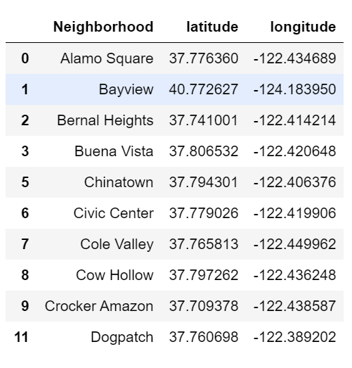

Spreadsheet 1 – San Francisco geospatial database quick view.

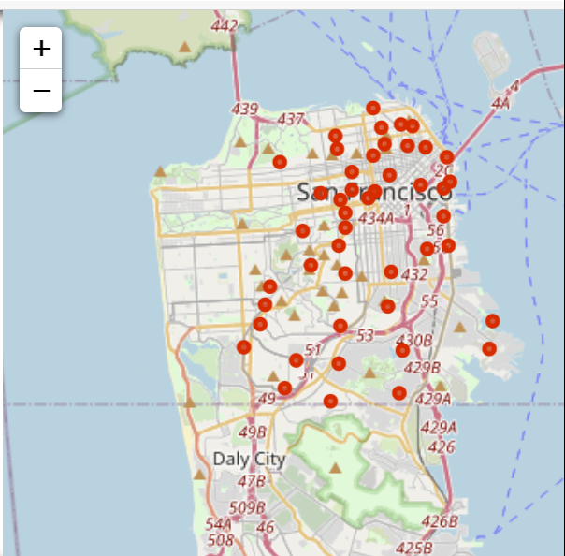

Figure 1 – San Francisco with Neighborhood locations, red dots.

* 1. **Geospatial Data**- New York District, New York

Utilizing a free dataset in json to format into a data frame then usse geolocator to determine latitude and longitude for maping.

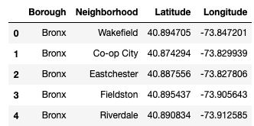

Spreadsheet 2- New York, NY geospatial data quick review

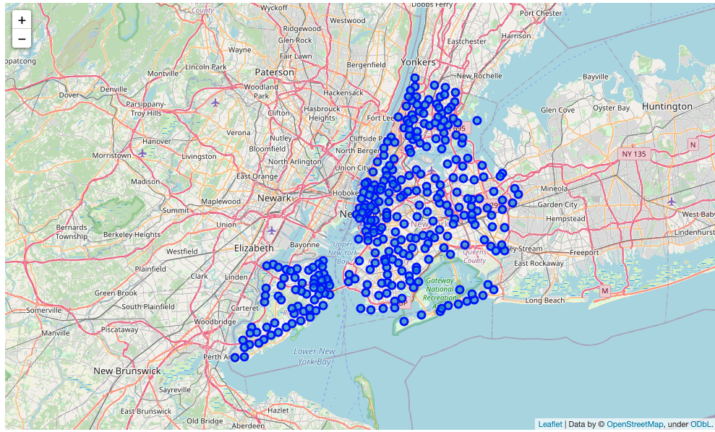

Figure 2- New York City, NY. With Neighborhoods locations, blue dots.

* 1. Geospatial Data of Restaurants
     1. San Francisco data of Foursquare API

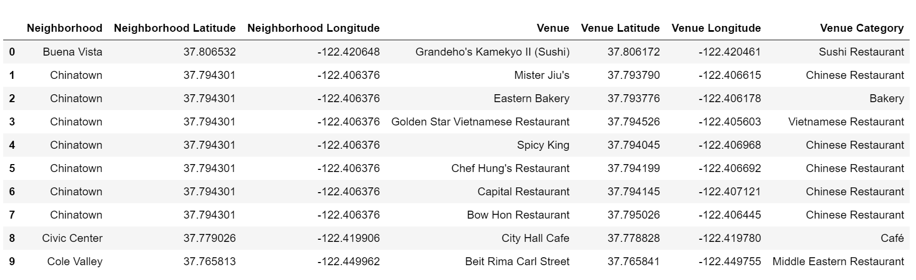

New York Districts data of Foursquare API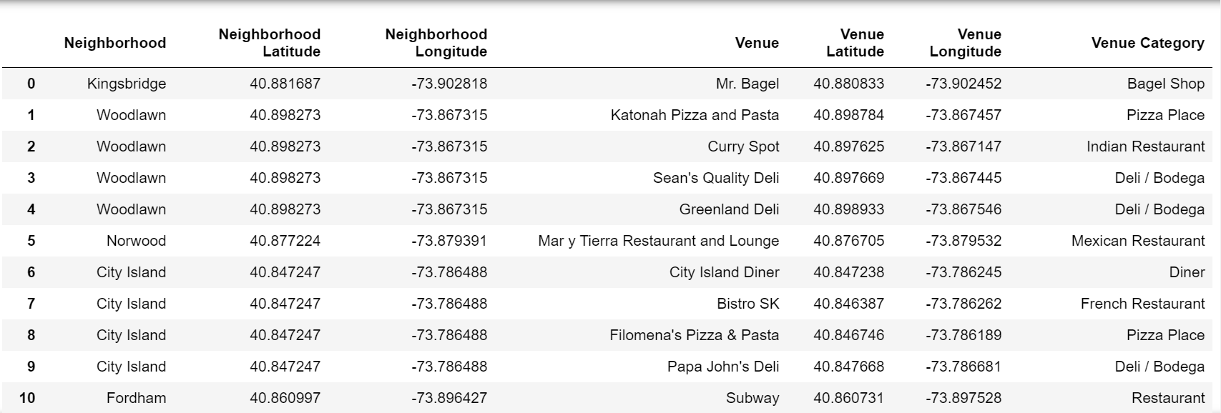

1. Methodology
   1. Compare total # of Restaurant in both locations
      1. Bar Charts/ Spreadsheet of total number

Matplotlib library was used to create bar charts of both San Francisco and New York data sets.

Top 3 Neighborhoods for San Francisco are Japantown, Mission Bay and Polk

Top 3 Neighborhoods for New York are Downtown, Hunters Point, and Inwood.

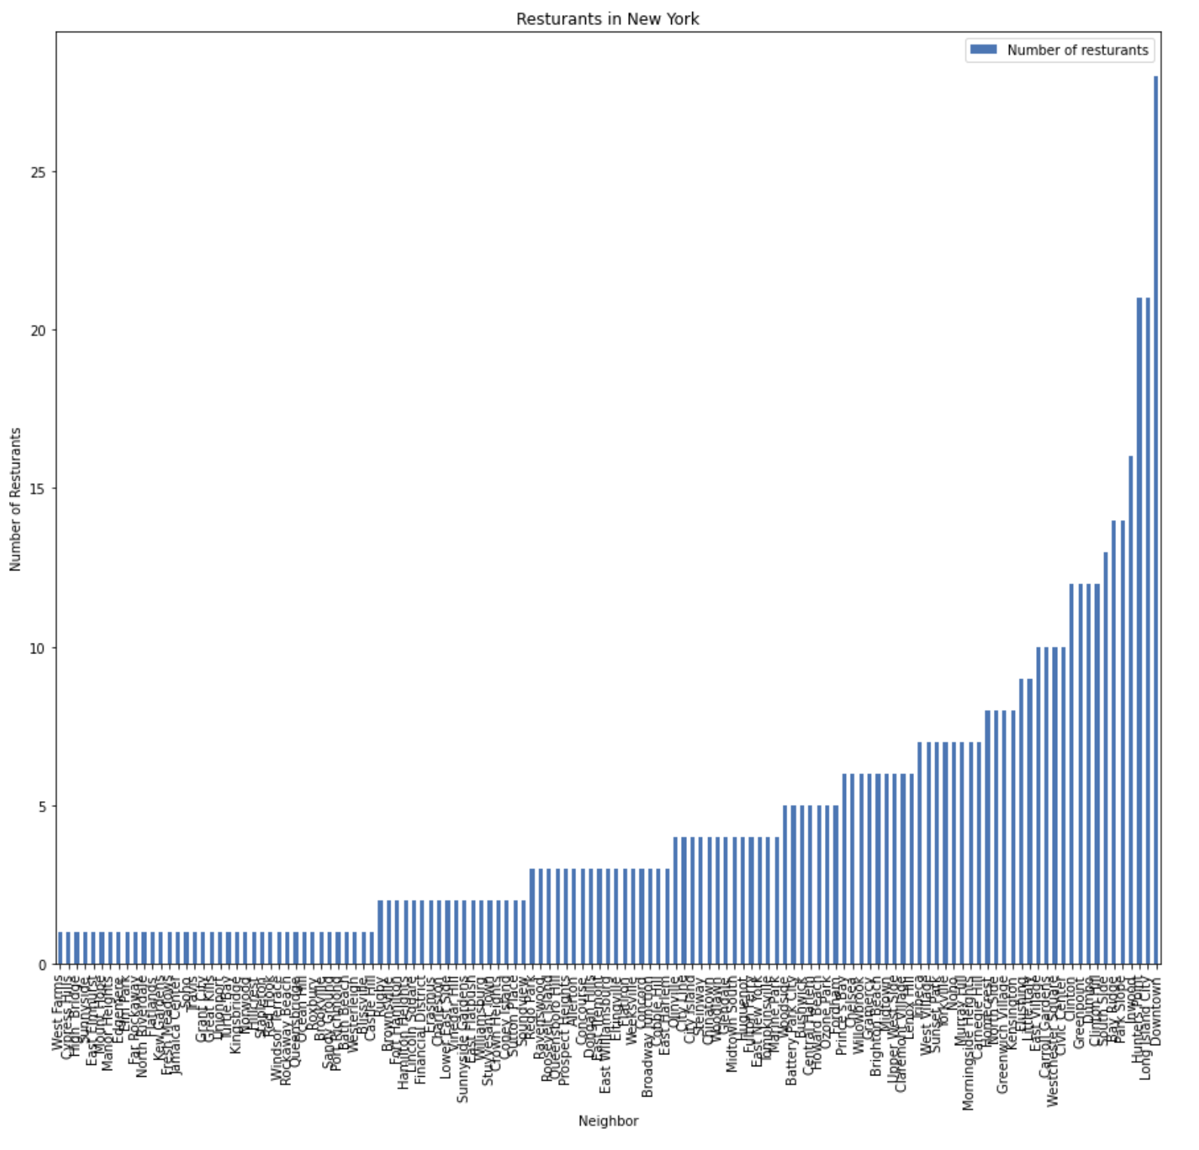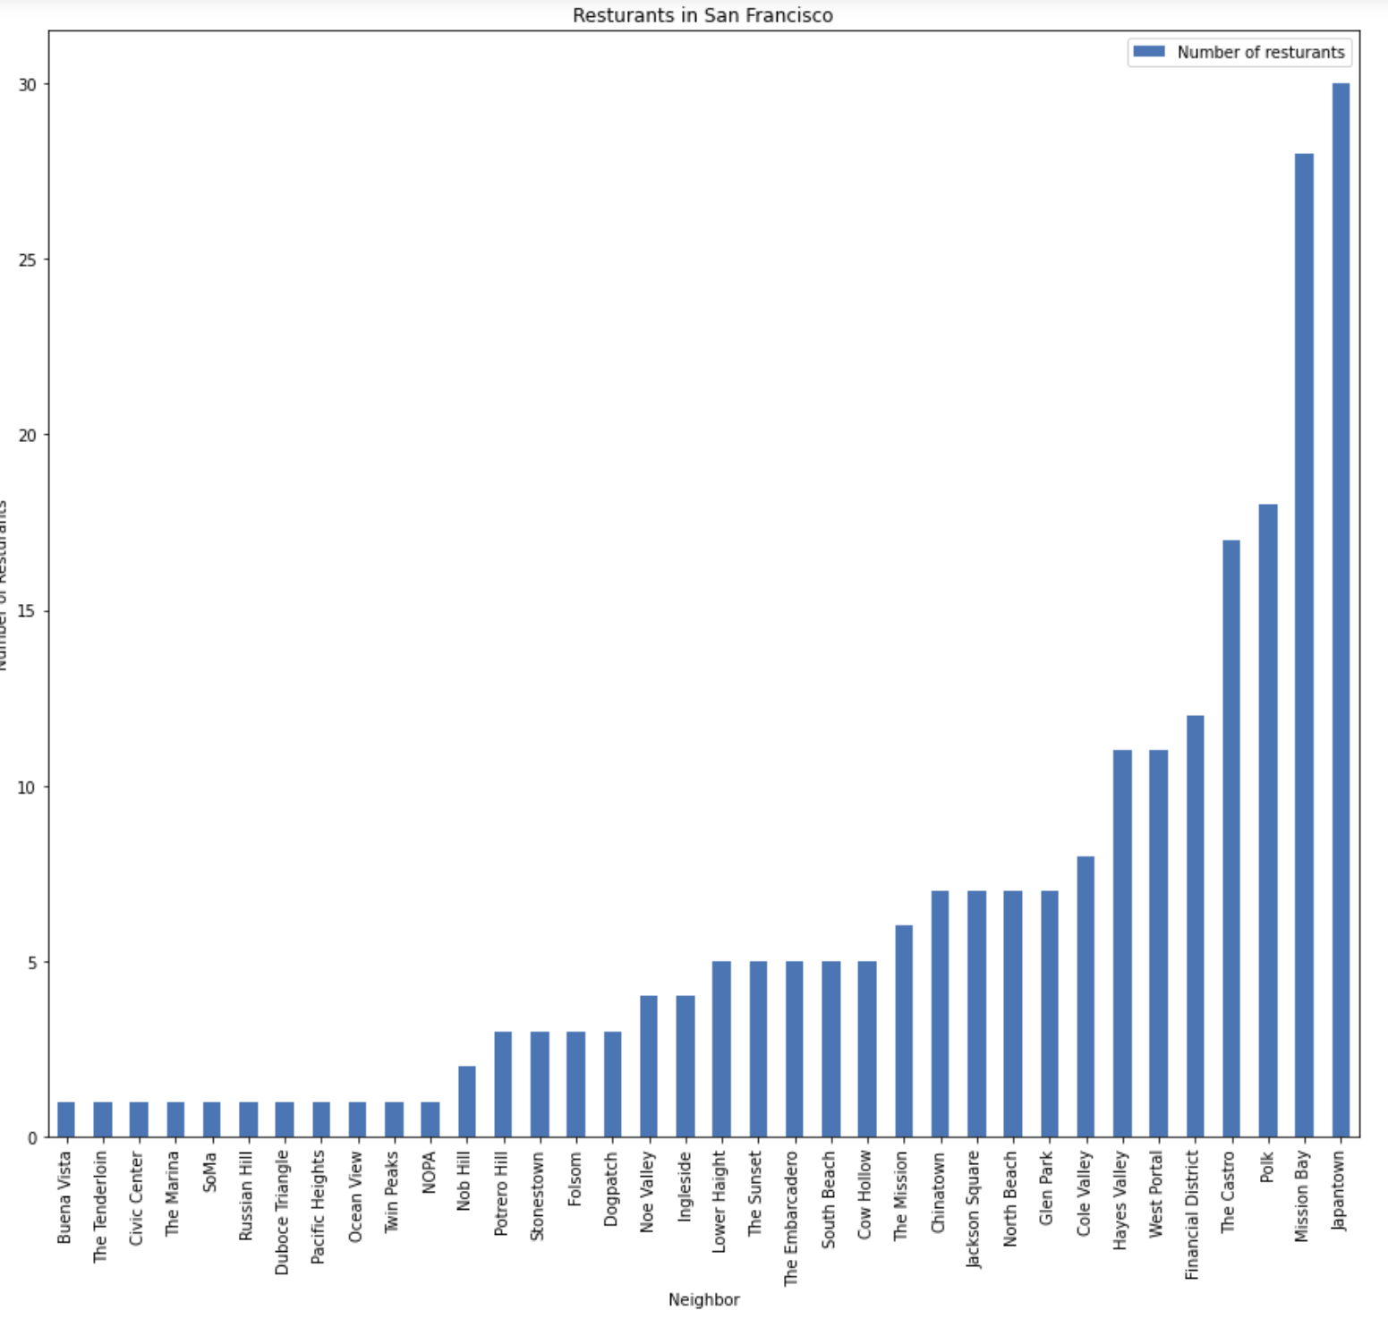

* 1. **Compare geospatial distribution per Restaurants in both locations**

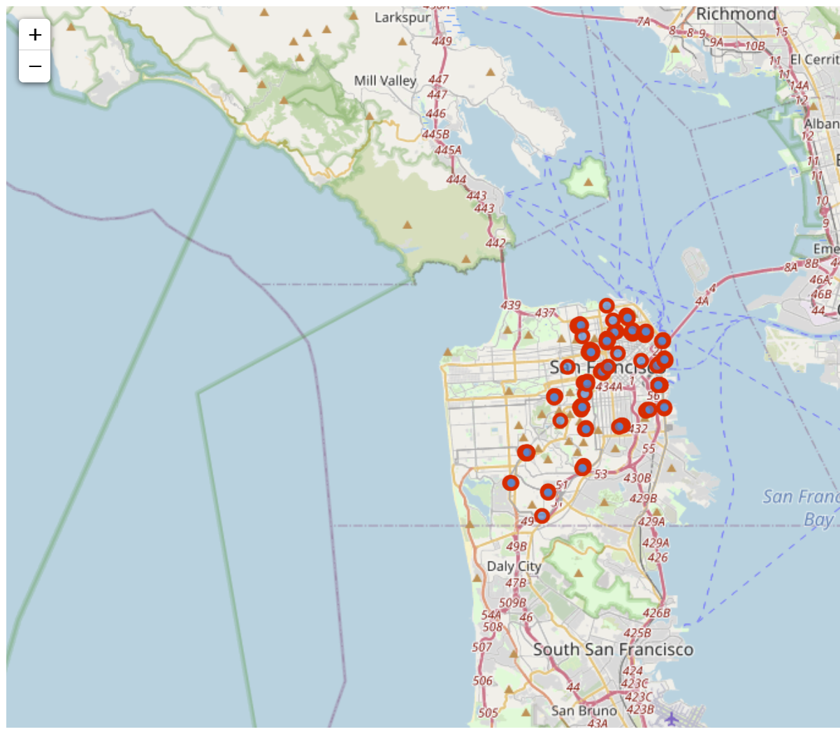

San Francisco Map with Restaurant locals in red.

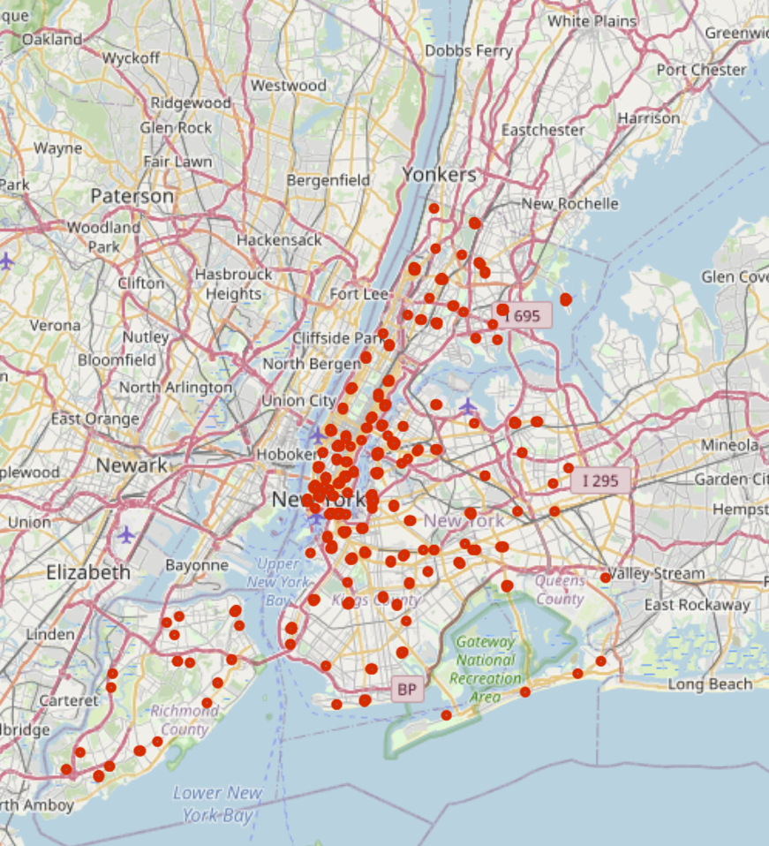

New York Map with Restaurant locals in red.

* 1. **K-means of Restaurants to determine rank of services in neighborhoods in both locations**

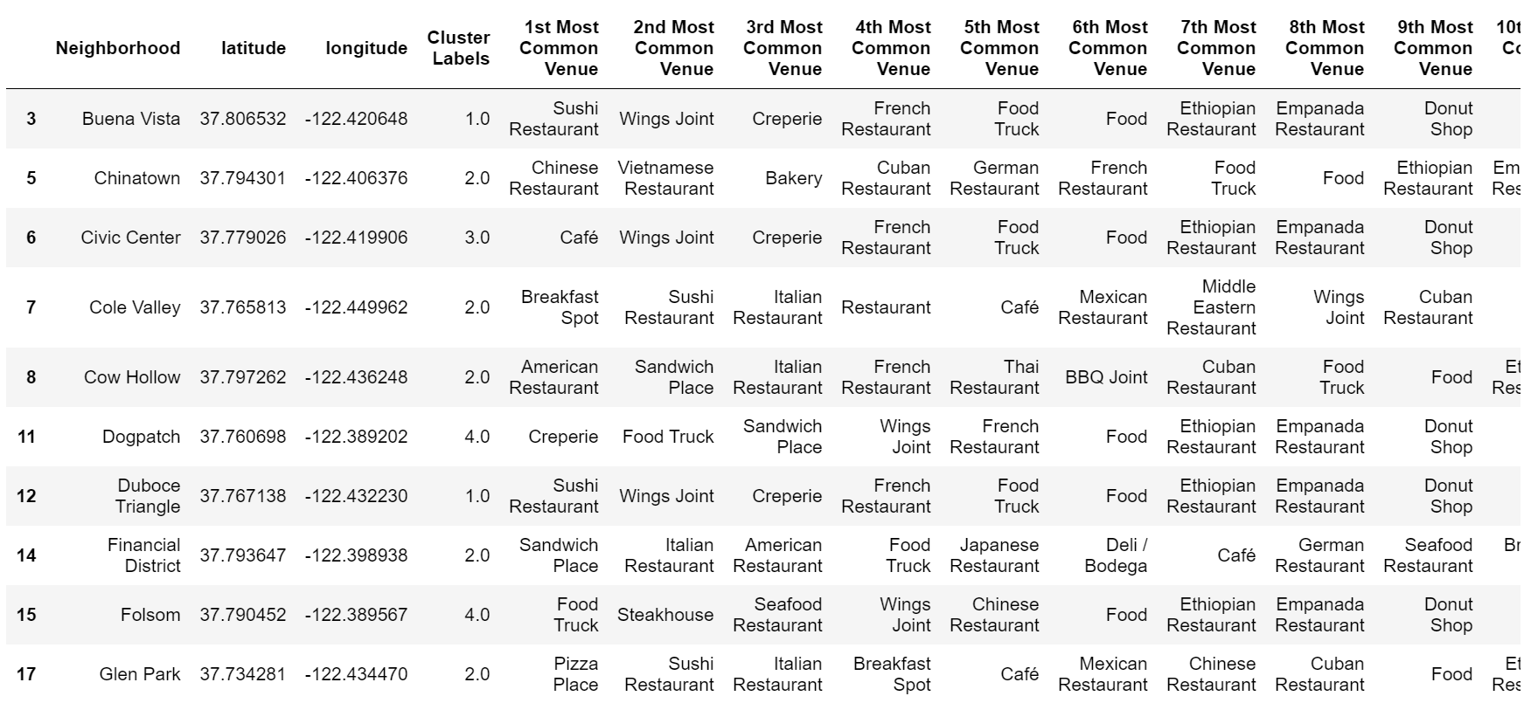

Table of San Francisco Data Frame

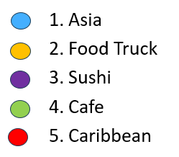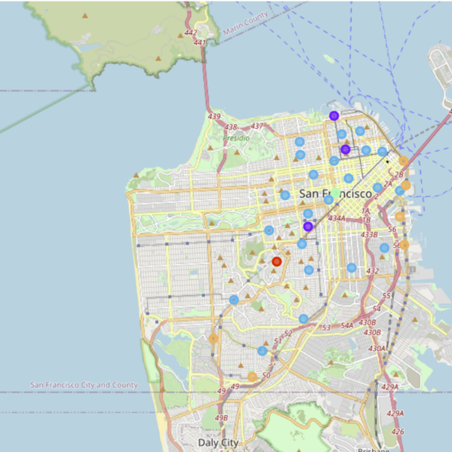

Map of Clusters in San Francisco

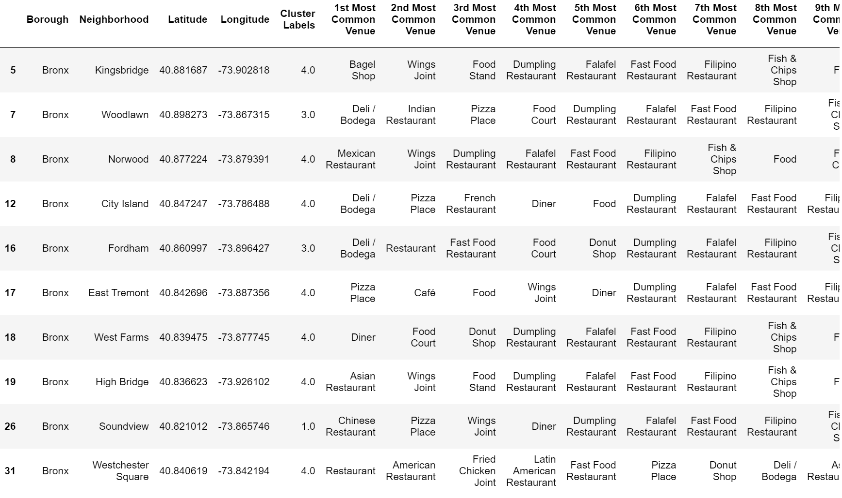

Table of New York data frame

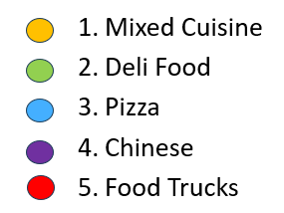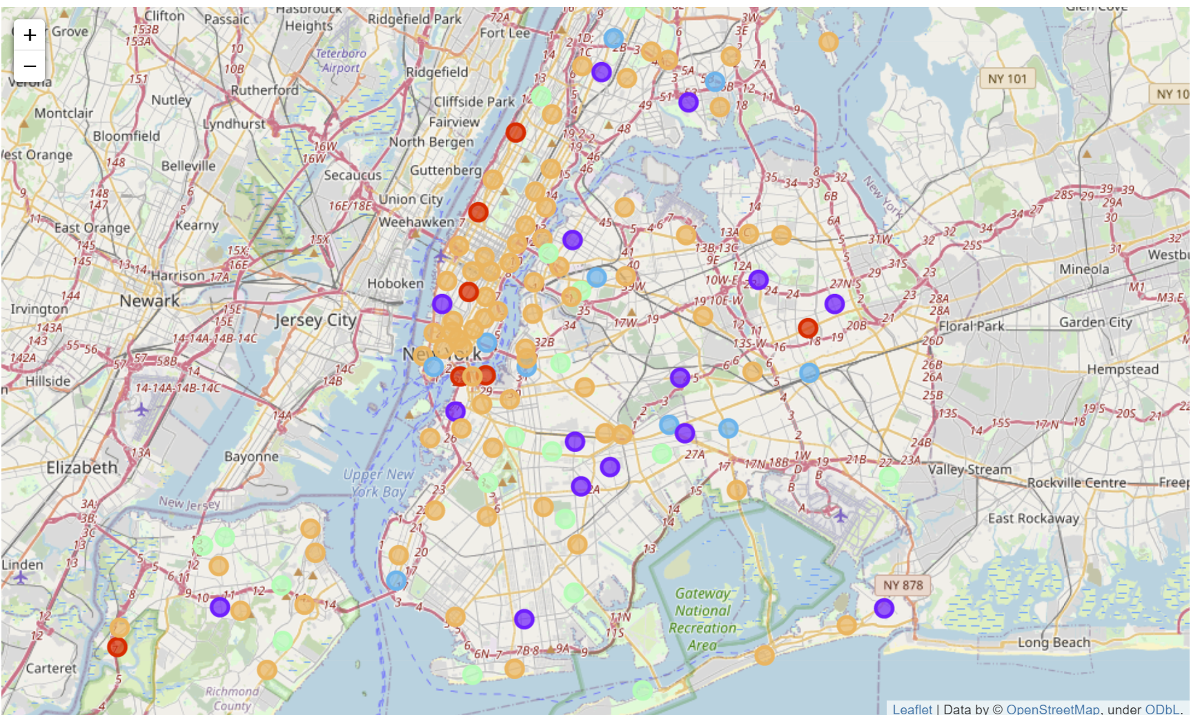

New York Map of Clusters using K-means

* + 1. **Maps to determine new office location**

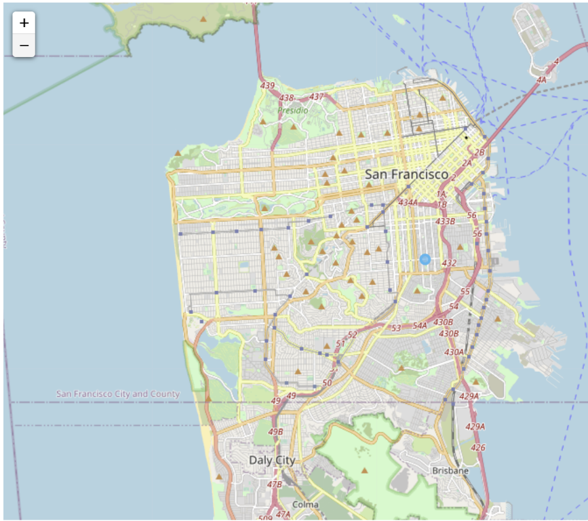

San Francisco map showing key neighborhood for potential central office location in The Mission neighborhood.

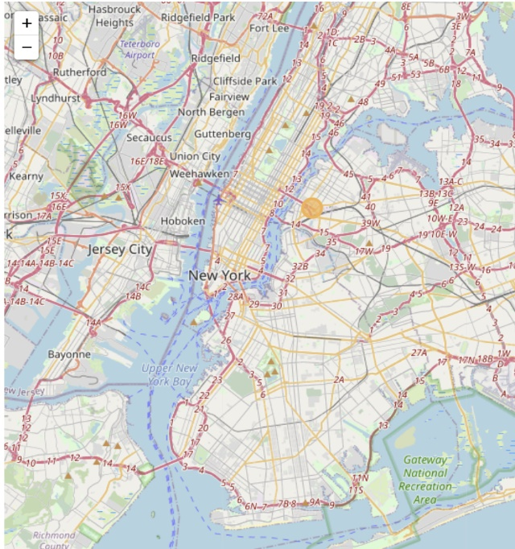

New York map showing key neighborhood for potential central office location in Long Island City neighborhood.

1. Results and Discussion
   1. What city to start?

Based upon the number restaurants in San Francisco at 227 has few venues than New York city having 587.

* 1. What services to focus on?

By utilizing clustering analysis of restaurant venues in neighborhoods it allows the user to compare in a ranked order. If the company started in New York city then most neighborhoods have mixed cuisines, but the Deli’s make up the second most restaurant scatter across New York and would be a focus customer base to be more efficient rather than trying to serve complex food varieties. In San Francisco the Asian restaurants would the main focus followed by serving food trucks.

* 1. Where do I open an office?

When determining the best central location multiple attributes need to be considered. E-bike need recharging service and employees need to have a location to distribution items. Locations were picked base upon the number of restaurants in a geographic high-density area. New York’s Long Island City had the most restaurants and The Mission neighborhood had the most restaurants in San Francisco geographic neighborhoods in San Francisco and New York

1. Conclusion

Utilizing this data science workflow in python to cross reference Foursquare venue data with geographic positioning of neighborhoods allows a startup business like E-Bike to determine potential customers to focus on and determine what services they can focus on like Deli’s in New York and Asia cuisines in San Francisco. The project also demonstrated a workflow to determine optimal central business locations for a business to maximize distribution of services to it customers.

End of Report